1. Team Introduction
Team Name: teamATE
2. Team Member Introductions (100 WORDS EACH)
Main Contact for Instructor: Sweeya Ghanta
Team Member 1:
Name: Sweeya Ghanta
GitHub Account: https://github.com/Sweeyya
Biography: My Name is Sweeya. I am a senior Computer Science student here at Georgia State University. I have been working through AI/ML for the past year, and have an interest in using those for games. I have also previously interned as an AI Engineer this past summer. I was born and raised in Georgia. Outside of school I love music and the arts. I have played piano for 11 years, and I love drawing, designing video games, working on 3d art, and just learning anything else I can.
Team Member 2:
Name: Joshoua Hossain
GitHub Account: https://github.com/Jhossain24
Biography: This is Joshoua (R) Hossain, and I am graduating this fall 2026 as a Computer Science major at Georgia State University. However, my professional identity is built on a unique combination of technical curiosity in software engineering and hands-on sales experience, which allows me to effectively tackle real-world business challenges. Originally from Bangladesh (South Asia), I have called Georgia home for over half a decade now. I bring a strong work ethic, cultural adaptability, and the ability to speak 6 languages & learning. I am actively strengthening my programming skills while also enhancing my communication and leadership abilities to drive success for any future employer.
Team Member 3:
Name: Arturo Hernandez
GitHub Account: https://github.com/Artvroo
Biography: My name is Arturo Hernandez and I’m graduating this Fall 2026 as a Computer Science major from Georgia State University. I have an interest in Software Engineering and Cybersecurity and plan to build a career in either of these or even combining them. I’m US born but Mexican. I have lived in Georgia my whole life but visit Mexico every year because I have a lot of family there. Specifically the state of Jalisco Mexico. I can read, write and speak 2 different languages. Outside of school and work I enjoy playing video games, soccer, tennis, and going to the gym. I look forward to contributing to this project to the best of my abilities.
Team Member 4:
Name: Jomari Ingol
GitHub Account: https://github.com/Marileanna
Biography: My name is Jomari, I am a senior graduating spring 2027. I am a Navy veteran and have 3 children, 2 boys and 1 girl, ages 24, 21 and 18. I currently am a bartender, but am so excited for a change in careers. Initially, I was a biology major, I completed 2 years at Clark Atlanta University. Later I decided to switch over to Computer Science so that I can pursue a career in bioinformatics.

3. First Virtual/In-person Meeting
Date of Meeting: 09/04/2026
Time: 2pm
Platform: Discord meeting
Meeting Agenda: Make the contract and discuss project ideas.
Photo of the Meeting:
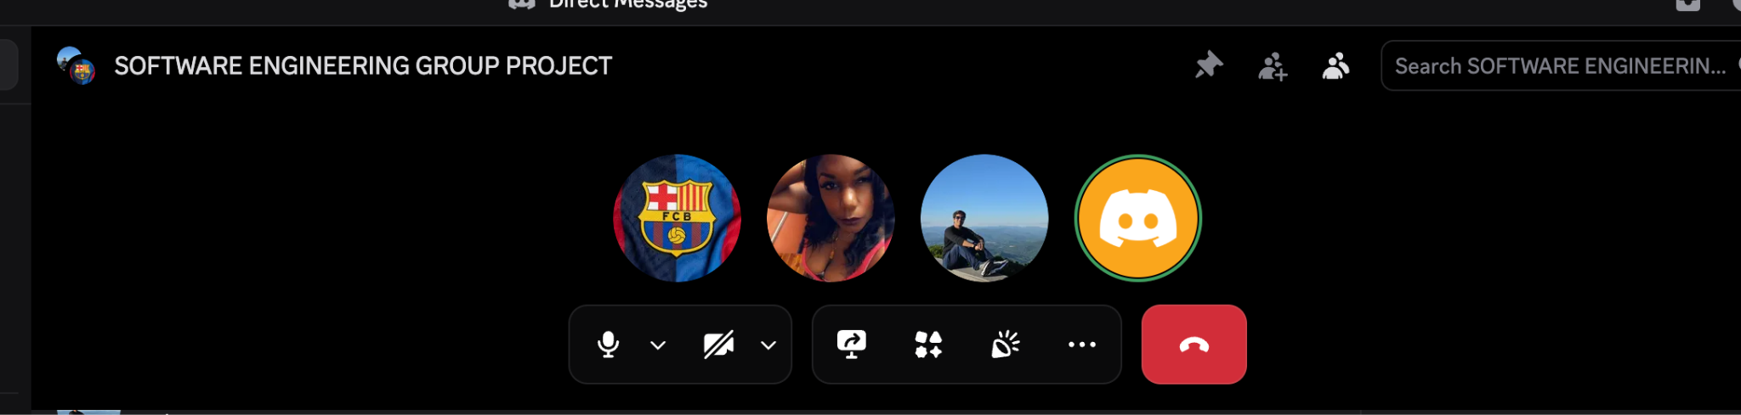

4. Team Agreement
We, the members of teamATE. agree to the following terms and guidelines for collaboration.

4.1. Methods of Communication & Response Times
Primary Communication: Discord meetings.
Secondary Communication: In-class/library meetings.
Response Times: 24 hours

4.2. Meeting Attendance
Meeting Schedule: Every Monday @ 9pm, Every Wednesday @ 9pm
Mandatory Attendance: at least 1 meeting a week
Notice for Absence: 1 hour

4.3. Running Meetings
Format (Online/In-Person): Discord & Library south
Platform/Location: Online/ GSU
Meeting Roles: Sweeya - Notetaking, Joshoua - Github; Arturo- Preparation; Jomari-Monitor

4.4. Meeting Preparation
Preparation Required: Yes
What to Prepare: Project discussion & team work distribution.

4.5. Version Control (Git/GitHub)
Repository Link: https://github.com/SWE-Class-Group-8/Group-Project4350
What to Commit: Code, documentation, meeting notes, design files
Commit Message Format: [Feature/Fix/Docs]: Brief description

4.6. Handling Member Absences
- Meeting notes
- Session recordings
4.7. Work Division and Progress
- Sweeya: Frontend design, AI applications, Structuring files and work
- Jomari: Managing schedule/deadlines & research
- Joshoua: Backend & watching commits
- Arturo: Backend security/infrastructure + code review

4.8. Submitting Assignments
-Sweeya (Primary)
-Arturo (Secondary)

4.9. Contingency Planning
- If a Member Drops Out: Divide the work amongst other team members, inform the instructor.

- If a Member Consistently Misses Meetings: If you miss 2 meetings or not responding back in the discord group (a) will be applied.

- If Academic Dishonesty is Suspected: We hold the person responsible and make them do their work again with proper guidelines.

Signatures: Jomari L. Ingol, Arturo Hernandez, Joshoua Romit Hossain, Sweeya Ghanta

